BOOK REPORT ON CHIAROSCURO AND SFUMATO
Reference material:
- Book “Leonardo da Vinci” by Walter Isaacson
- Book “Art: The Definitive Visual Guide” by Ross King and various Consultants
- www.Wikiart.org
- www.thoughtco.com painting styles
- www.visual-arts-cork.com
- Other internet sources

CHIAROSCURO
Chiaroscuro is derived from two Italian words, namely:
Chiaro meaning clear or bright, and
Oscuro meaning obscure or dark
It is the treatment of light and shade in drawings and paintings. Before the Renaissance time, paintings may have had some shading and some highlights on figures but mostly did not convey the illusion of three dimensionality on a two-dimensional surface, i.e. there is little effect of contrasted light and shadow created by light falling unevenly or from a particular direction on something.
Examples: Cimabue’s Madonna Enthroned, ca 1280
Fra Angelico’s Annunciation, ca 1437
Both paintings/murals are wonderful but the figures appear fairly flat.

Starting with the Italian Renaissance (ca. 1400 to 1525) paintings started to show an illusion of three dimensionality. Moving from egg tempera, which is fast drying, to oil-based paints (slow drying) allowed the artists more time to show figures with believable emotions and facial features.
Examples: Filippo Lippi’s Madonna with Child and two Angels, ca 1450
Leonardo da Vinci’s Benois Madonna, ca 1475
Botticelli’s The Birth of Venus, ca 1485
Leonardo da Vinci’s Lady with an Ermine, ca 1489
Lippi’s Madonna painting show high lighted face of the Madonna drawing in or focusing the viewer to her face. The details show however outlines of the bodies. Some three dimensionality is also conveyed due overlap of the bodies of child and the two angels. Da Vinci’s Madonna has a blue dress that ranges from almost white to almost black. The detail of foot shows that at the time when he painted this, he still used some outlines of body parts (foot). The Madonna painting shows highlights on her face and on the child. Such skillful use of light and dark paints to define three-dimensional shape became known as chiaroscuro. Another example is da Vinci’s Lady with an Ermine. He artificially expands the range of luminance, creating a greater sense of depth. Every object has a common range of value but he does not change or vary the hue like Michelangelo did a few years later. Typically, he used mid-range colors all having a similar range of contrasts. He does use some lighter and darker colors but not in the extreme. Botticelli’s Birth of the Venus also shows the use of chiaroscuro but also uses outlines around body parts. Again, all four paintings are beautiful and have some chiaroscuro conveying three-dimensionality (highlights and dark gradations).
Quote from Leonardo da Vinci about his technique:
I would remind you O Painter! To dress your figures in the lightest colors you can, since, if you put them in dark colors, they will be in too slight relief and inconspicuous from a distance. And this is because the shadows of all objects are dark. And if you make a dress dark there is little variety between the lights and shadows, while in light colors there will be greater variety.
Leonardo da Vinci’s version of chiaroscuro technique involved varying the darkness of a particular color by adding black pigments to it. Other artists archived chiaroscuro by employing different colors for the light and the dark/shadow parts of an object. Sometimes this technique is called cangiante (translated to changing in English).
Examples: Michelangelo’s Prophet Daniel in ceiling of Sistine Chapel, ca 1508
Using chiaroscuro in the highlighted cloth (different shades of yellow) and cangiante in the dark areas of the cloth.

Raphael’s School of Athens, ca 1510
Painting shows both chiaroscuro and cangiante techniques.
Artists like Verrochio, Ghirlandaio, da Vinci, and others started to study drapery and other cloth items to view how exactly these garments can be painted with more realistic details and with more chiaroscuro.
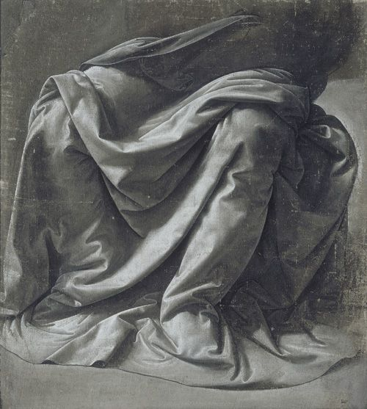
SFUMATO
Sfumato is derived from Italian and translates into English meaning gradient, nuanced, shaded.
It is the technique of allowing tones and colors to shade gradually into one another, producing softened outlines or hazy forms. It can be likened to smoke dissipating or vanishing into the air. Another way to explain is that Sfumato refers to the subtle gradation of tone (or value) used to obscure sharp edges and create a synergy between lights and shadows in a painting. It is a technique for softening the transition between colours resulting in blurred outlines and mellowed colors that allow one form to merge with another. For this reason, Sfumato is sometimes described as “Leonardo’s smoke”.
Examples: Leonard da Vinci’s Mona Lisa, ca 1503
Leonardo da Vinci used the technique of sfumato in this most famous painting. For the painting as a whole, he selected a range of unifying mid-tones, especially the blues, greens, and earth colors, which had similar levels of saturation (or chroma). He avoided the most luminous colors for his bright areas, which could break the unity or harmony of the painting, and created a subdued flavor in the painting.
Mona Lisa has an enigmatic or elusive smile which he achieved with shadowing in the corner of the eyes and mouth. He created an image that has no lines or edges around a figure or parts of a figure, producing a soft hazy effect. Compare this to the head of Venus in Botticelli’s painting: it shows a clear outline of cheeks and chin with dark paint.

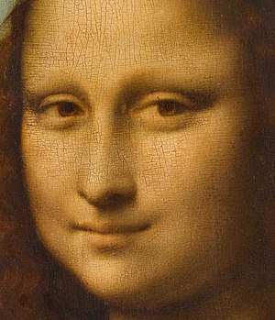

Detail of the face of Mona Lisa showing the use of sfumato, particularly in the shading around the eyes.

Leonardo da Vinci himself described sfumato as a blending of colours "without lines or borders, in the manner of smoke". It is as if a veil of smoke has been placed between the painting and the viewer, toning down the bright areas and lightening the dark ones, so as to produce a soft, imperceptible transition between the differing tones. To achieve this effect, he used a number of translucent glazes to generate the gradual tonal spectrum from dark to light.

TENEBRISM
Both Chiaroscuro and Tenebrism are techniques concerned with the treatment of light and shadow. Sometimes tenebrism is described as a strong chiaroscuro or a violent contrast between light and dark. The two techniques are not exactly the same. Chiaroscuro is a shading technique that give a two-dimensional body a sense of three-dimensionality. Tenebrism on the other hand is a light-dark compositional technique by which some areas of the painting are kept dark (black). The dark in tenebrism is like negative space whereas the dark or shadow in chiaroscuro contributes to the positive form (contributes to the illusive form of three-dimensionality).
Some of Caravaggio’s paintings show clearly the tenebrism technique of dramatic lighting with negative space and the chiaroscuro technique of creating illusive three-dimensionality.
Example: Caravaggio’s The Calling of St Matthew, ca 1600
The Baroque period of painting started in ca 1600 with early baroque, followed by high baroque and late baroque. Caravaggio was at the leading edge of baroque. Other important painters using techniques of chiaroscuro and tenebrism include Rubens, Rembrandt, Velasquez, Vermeer, and others.
Example: Rembrandt’s Self Portrait, ca 1660
Again, a wonderful painting. Looking at a close-up of the face, it is definitely not sfumato like the Mona Lisa by Leonardo da Vinci. But the technique of chiaroscuro is done masterfully.

Leonardo da Vinci
15 April 1452 – 2 May 1519

Mona Lisa: Painted 1503

Raphael (Raffaello Sanzio)
28 March 1483 – 6 April 1520

Portrait of Baldassare Castiglione: Painted 1516

Caravaggio (Michelangelo Merisi)
28 September 1571 – 18 July 1610

The Incredulity of Saint Thomas: Painted 1601

Rembrandt (Rembrandt Harmenszoon van Rijn)
15 July 1606 – 4 October 1669

The Girl in a Picture Frame: Painted 1641

Diego Velasquez
6 June 1599 – 6 August 1660

Portrait of Juan de Pareja: Painted 1650

What Is Hue?
At its most basic level, "hue" is art speak for the actual color of a pigment or object. But the use of the term hue is more complicated when it comes to the names that paint manufacturers give their paint colors.
This is because the term “hue” is used to indicate that a color is not made from the pigment(s) that were originally used for that paint but modern equivalents that are either cheaper or more lightfast. Judging a hue is the first step in color mixing as it identifies what tube of paint to reach for.

What Is Value?
Value or tone is a measure of how light or dark a color is, without any consideration for its hue. Think of it as taking a black-and-white photo of a subject where you clearly see what’s in the photo but everything is in grayscale.
The problem with a color’s value or tone is that how light or dark it seems is also influenced by what is going on around it. What appears light in one circumstance can appear darker in another circumstance, for instance when it’s surrounded by even lighter tones.

What Is Chroma?
The chroma, or saturation, of a color is a measure of how intense it is. Think of it as “pure, bright color”, compared to a color diluted with white, darkened by black or gray, or thinned by being a glaze.
Variations in chroma can be achieved by adding different amounts of a neutral gray of the same value as the color you're wanting to alter.

