John Singer Sargent's Painting Techniques
Notes derived from a number of resources including: Craig Mullins
20 Master's Paintings
(on Pinterest)

General Procedure
Painting is an interpretation of tone through the medium of color drawn with the brush. Use a large brush. Do not starve your palette. Accurately place your masses with the charcoal, then lay in the background about half an inch over the border of the adjoining tones, true as possible, then lay in the mass of hair, recovering the drawing and fusing the tones with the background, and overlapping the flesh of the forehead. For the face lay in a middle flesh tone, light on the left side and dark on the shadow side, always recovering the drawing, and most carefully fusing the flesh into the background. Paint flesh into background and background into flesh, until the exact quality is obtained, both in color and tone so the whole resembles a wig maker's block.

Then follows the most marked and characteristic accents of the features in place and tone and drawing as accurate as possible, painting deliberately into wet ground, testing your work by repeatedly standing well back, viewing it as a whole, a very important thing. After this take up the subtler tones which express the retiring planes of the head, temples, chin, nose, and cheeks with neck, then the still more subtle drawing of mouth and eyes, fusing tone into tone all the time, until finally with deliberate touch the high lights are laid in, this occupies the first sitting and should the painting not be satisfactory, the whole is ruthlessly fogged by brushing together, the object being not to allow any parts well done, to interfere with that principle of oneness, or unity of every part; the brushing together engendered an appetite to attack the problem afresh at every sitting each attempt resulting in a more complete visualization in the mind.

Sargent's Notes
1. Painting is an interpretation of tone. Colour drawn with a brush.

2. Keep the planes free and simple, drawing a full brush down the whole contour of a cheek.

3. Always paint one thing into another and not side by side until they touch.

4. The thicker your paint—the more your color flows.

5. Simplify, omit all but the most essential elements—values, especially the values. You must clarify the values.

6. The secret of painting is in the half tone of each plane, in economizing the accents and in the handling of the lights.

7. You begin with the middle tones and work up from it . . . so that you deal last with your lightest lights and darkest darks, you avoid false accents.

8. Paint in all the half tones and the generalized passages quite thick.

9. It is impossible for a painter to try to repaint a head where the understructure was wrong.
PALETTE: Silver White, Naples Yellow, Yellow Ochre, Ochre dew (English Red), Red Ochre, Vermillion, Ivory or Coal Black, and Prussian Blue.

Sargent's notes above are from George Pratt via James Gurney. He found these nuggets in the library when he was a student at Pratt Institute.

Start
According to his pupil, Miss Heyneman, with a bit of charcoal he placed the head with no more than a few careful lines over which he passed a rag, so that it was a perfectly clean grayish colored canvas (which he preferred), faintly showing where the lines had been. Then he began to paint. At the start he used sparingly a little turpentine to rub in a general tone over the background and to outline the head (the real outline where the light and shadow meet, not the place where the head meets the background), to indicate the mass of the hair and the tone of the dress. The features were not even suggested. This was a matter of a few moments. For the rest he used his color without a medium of any kind, neither oil, turpentine or any other mixture.

He put in this general outline very rapidly, hardly more than smudges, but from the moment that he began really to paint, he worked with a kind of concentrated deliberation, a slow haste so to speak, holding his brush poised in the air for an instant and then putting it just where and how he intended it to fall.

Painting the Head
He painted a head always in one process, but that could be carried over several sittings. He never attempted to repaint one eye or to raise or lower it, for he held that the construction of a head prepared the place for the eye, and if it was wrongly placed, the understructure was wrong, and he ruthlessly scraped and repainted the head from the beginning.

To watch the head develop from the start was like the sudden lifting of a blind in a dark room. Every stage was a revelation. For one thing he often moved his easel next to the sitter so that when he walked back from it he saw the canvas and the original in the same light, at the same distance, at the same angle of vision. He aimed at once for the true general tone of the background, of the hair, and for the transition tone between the two.

At first he worked only for the middle tones, to model in large planes, as he would have done had the head been an apple. In short, he painted as a sculpture models, for the great masses first, but with this difference that the sculptor can roughly lump in his head and cut it down afterwards, while the painter, by the limitations of his material, is bound to work instantly for an absolute precision of mass, in the color and outline he intends to preserve.
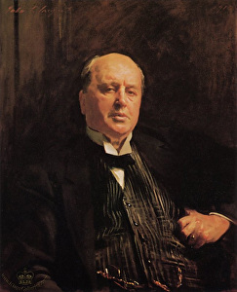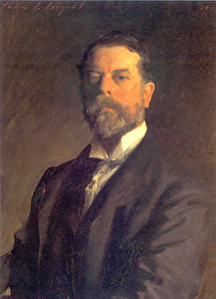
“Portrait of Henry James” and “Self-portrait” by John Singer Sargent

Accents and Features
Until almost at the end there were no features or accents, simply a solid shape growing out of and into a background with which it was one. When at last he did put them in, each accent was studied with an intensity that kept his brush poised in mid-air until eye and hand had steadied to one purpose, an then...bling!

The stroke resounded almost like a note of music. It annoyed him very much if the accents were carelessly indicated, without accurate consideration of their comparative importance. They were, in a way, the nails upon which the whole structure depended for solidity.

Details, he was convinced, would take care of themselves. He once advised a student: "Do not concentrate so much on the features. Paint the head. The features are only like spots on an apple."

Effortless Virtuosity
Should the painting not be satisfactory, the whole is ruthlessly fogged by brushing together, the object being not to allow any parts well done, to interfere with that principle of oneness, or unity of every part; the brushing together engendered an appetite to attack the problem afresh at every sitting each attempt resulting in
a more complete visualization in the mind. The process is repeated until the canvas is completed.

Sargent plotted his major canvases at length, often scraped away days if not weeks of effort, sometimes made second versions of a finished composition when the traces of the campaign appeared too evident. He strove hard, successfully, to make the result seem effortless. With his water colours he seems to have simply discarded the sheet and restarted or simply restricted access to those he considered inadequate.
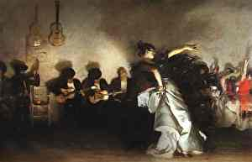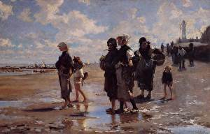
“El Jaleo” and “Oyster Gatherers of Cancale” by John Singer Sargent

Pigment
“You do not want dabs of color, you want plenty of paint to paint with.” Having scraped the palette clean he put out enough paint so it seemed for a dozen pictures.

The range of pigments was quite wide but did not include every pigment available at that time. He regularly used Mars yellow (a synthetic iron oxide) and cadmium yellow; viridian and emerald green, sometimes mixed; vermilion and Mars red, both alone and mixed; madder; synthetic ultramarine or cobalt blue; and ivory black, sienna, and Mars brown. The dark backgrounds of many portraits include a mixture of ivory black, Mars brown, and a generous quantity of paint medium, which gives a colour similar to the traditional Vandyck brown.

Mediums
Sargent's liberal use of oil and turpentine to thin his darker paint is confirmed by the dribbles seen on tacking margins.

Balance of Shape and Colour
Having achieved the fundamental laying-in of the design, Sargent continued to develop and modify the image, by shifting the boundary between the figure and the background, to achieve a deliberately sought-after fine balance of shape and colour.

Brushes
“Painting is quite hard enough without adding to your difficulties by keeping your tools in bad condition. You want good thick brushes that will hold the paint and that will resist in a sense the stroke on the canvas.”

Canvas
A characteristic of Sargent's supports is an excess of primed canvas, in some cases several inches, lapped round the back of the stretcher. This excess of canvas provided yet further opportunity for Sargent to make modifications.

His portrait canvases all have a plain weave' (that is, with one warp and one weft thread), generally very fine, though a few are of medium weight.

The colour of the priming was either grey or white. The grey primings contribute to the overall cool appearance of these works, and serves to provide a mid-tone which also intensified the colour of the brown, thinly-painted backgrounds which Sargent frequently used in portraits.

Brushwork
“The thicker you paint, the more color flows.”

The hills of paint vanished from the palette, yet there was no heaviness on the canvass: although the shadow was painted as heavily as the light, it retained its transparency.

If you see a thing transparent, paint it transparent; don't get the effect by a thin strain showing the canvas through. That's a mere trick. The more delicate the transition, the more you must study it for the exact tone. The lightness and certainly of his touch was marvelous to behold.

"Always use a full brush and a larger one than necessary." Paint with long sweeps, avoiding spots and dots ('little dabs'). Never think of other painters' pictures ... but follow your own choice of colors with exact fidelity to nature.

Economy of effort in every way, the sharpest self-control, the fewest strokes possible to express a fact, the least slapping about of purposeless paint.

Paint all the half tones and general passages quite thick -- and always paint one thing into another and, not side by side until they touch.

The width of his brushes varied considerably, with fine points being used for subtle details of faces, in contrast to the sweeping strokes up to an inch in diameter which he used to capture folds of fabric, in the later stages of painting. Unfinished portraits show that initial paint-layers have brushstrokes from quarter-inch and half-inch brushes: the boldest, broadest strokes were used for finishing.
20 Exceptional Drawings and Sketches
(on Pinterest, by contemporary artists)

Drawing
He believed, with his teacher Carolus-Duran, that painting was a science which it was necessary to acquire in order to make of it an art. You must draw with your brush as readily, as unconsciously almost as you draw with your pencil.

A formula of his for drawing was: Get your spots in their right place and your lines precisely at their relative angles. The method he tried to inculcate was to lay in the drawing afresh at every sitting, getting in one combined effort a complete interpretation of the model. The skull to articulate properly upon the vertebrae. The same with all the limbs, a keen structural easy supple, moveable machine, every figure with its own individual characteristic as like as possible, an accomplishment requiring enormous practice and experience with charcoal, but taken as a goal to aim at very desirable, a method he followed in his own painting.

He advised doing a head for a portrait slightly under life-size, to counteract the tendency to paint larger than life. Even so he laid in a head slightly larger than he intended to leave it, so that he could model the edges with and into the background.

When drawing from the model, never be without the plumb line in the left hand. Everyone has a bias, either to the right hand or the left of the vertical. The use of the plumb line rectifies this error and develops a keen appreciation of the vertical.
He then took up the charcoal, with arm extended to its full length, and head thrown well back: all the while intensely calculating, he slowly and deliberately mapped the proportions of the large masses of a head and shoulders, first the pose of the head upon the neck, its relation with the shoulders. Then rapidly indicate the mass of the hair, then spots locating the exact position of the features, at the same time noting their tone values and special character, finally adding any further accent or dark shadow which made up the head, the neck, the shoulders and head of the sternum.

You can't do sketches enough. Sketch everything and keep your curiosity fresh.
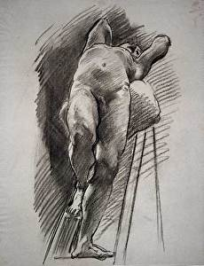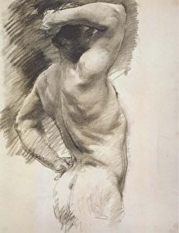
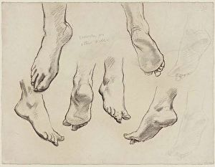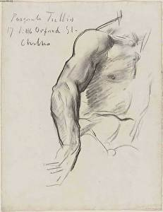
Drawings by John Singer Sargent

On Likeness
It was a common experience for Sargent, as probably for all portrait painters, to be asked to alter some feature in a face, generally the mouth. Indeed, this happened so often that he used to define a portrait as "a likeness in which there was something wrong about the mouth." He rarely acceded, and then only when he was already convinced that it was wrong.

I do not judge, I only chronicle. Every time I paint a portrait I lose a friend. I don't dig beneath the surface for things that don't appear before my own eyes.

View from a Distance
Sargent would press home the fact that the subtleties of paint must be controlled by continually viewing the work from a distance. Stand back -- get well away -- and you will realize the great danger there is in overstating a tone. Keep the thing as a whole in your mind. Tones so subtle as not to be detected on close acquaintance can only be adjusted by this means.

In painting a picture he would retreat a few steps from the canvas and then once more advance with his brush balanced in his hand as though it were a rapier and he were engaged in a bout with a fencing master.

Those who watched Sargent painting in his studio were reminded of his habit of stepping backwards after almost every stroke of the brush on the canvas, and the tracks of his paces so worn on the carpet that it suggested a sheep-run through the heather. He, too, when in difficulties, had a sort of battle cry of "Demons, demons," with which he would dash at his canvas.

Sargent On His Method
“As to describing my procedure, I find the greatest difficulty in making it clear to pupils, even with the palette and brushes in hand and with the model before me; to serve it up in the abstract seems to me hopeless.”

“Color is an inborn gift, but appreciation of value is merely training of the eye, which everyone ought to be able to acquire.”

By Sargent's method the head developed by one process. Every brush stroke modeled the head or further simplified it. He was careful to insist that there were many roads to Rome, that beautiful painting would be the result of any method or no method, but he was convinced that by the method he advocated, and followed all his life, a freedom could be acquired, a technical mastery that left the mind at liberty to concentrate on a deeper or more subtle expression.

Painting From Life
Sargent, when he painted the size of life, placed his canvas on a level with the model, walked back until canvas and sitter were equal before his eye, and drew with his brush, beginning with the shadows, and gradually evolving his figure from the background by means of large, loose volumes of shadow, half tones and light, regardless of features or refinements of form. He painted with large brushes and a full palette, using oil and turpentine freely as a medium. When he repainted, he would smudge and efface the part he wished to reconstruct, and begin again from a shapeless mass.

Sargent on Style
Sargent believed that styles were techniques to be used rather than an end representation in themselves, and said that knowledge of a particular style: "does not make a man an Artist any more than the knowledge of perspective does - it is merely a refining of one's means towards representing things and one step further away from the hieroglyph".
20 Exceptional Watercolors
(on Pinterest, by contemporary artists)

Sargent's Watercolor Technique
Sargent used a more brilliant palette for watercolors than he did for his portraits, reserving watercolors for landscapes and non-notable people, such as his friends and the natives he came across during his travels. The Impressionist philosophy of the time was that the effects of sunlight could be best captured outdoors, a philosophy that Sargent followed.
Sargent, on painting a watercolor “Make the best of an emergency.”

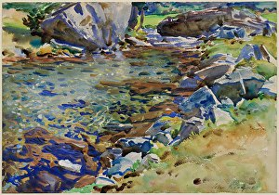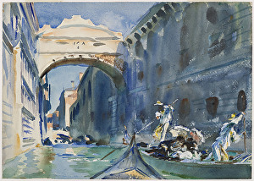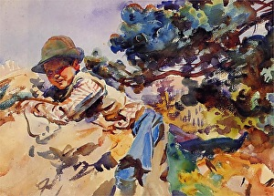
“Brook Among Rocks”, “Bridge of Sighs” and “Boy on a Rock” watercolors by John Singer Sargent

Materials for Watercolor
Pigments: Alizarin Carmine, Brown Pink, Burnt Sienna, Cadmium Yellow Pale, Chrome Yellow, Cobalt Blue, Gamboge, Lamp Black, Rose Madder, Ultramarine Blue, Vandyke Brown, Scarlet Vermillion, Deep Vermillion, Viridian, and an opaque white (typically zinc white)
Signature colors of Sargent are Ultramarine Blue and Vandyke Brown.; his favorite green was Viridian.
Evidently used pan colors rather than tubes
Cold pressed paper, mostly half-sheets
Sargent was a friend of Monet and often painted en plein air. Sargent started using an expanded range of colors after 1876, but prior to that he captured the tonal qualities of light, but played down its color aspects.

Special Techniques Used with Watercolor 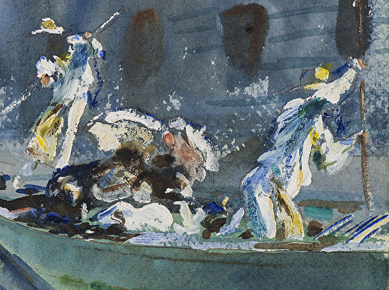
Gouache,
Gum Arabic,
Ox gall,
Scratching,
Pen and ink,
Straight edge on architecture
Washes over wax resist to create textures.
"Bridge of Sighs" detail
by John Singer Sargent
Sargents Use of Opaques in Watercolor
Thick use of gouache whenever he needed it
Often lay down a spot of white gouache and then, after it dried, went over with transparent color

Creating the Effect of Light in Watercolor
Exaggerates the effect of light, shadows sometimes lighter than expected,
Reserves of white paper and strategic color lifting,
Sponged wet washes into each other while preserving the white of the paper for the lights,
Used wax as a resist to give a scintillating effect,
Scratched out lines with the end of a brush or a knife,
Might use gouache or China white for highlights.

Darks in Watercolor
Sargent avoided black, and generally mixed bright blues with browns of the same value.

Sargent's Process for Painting a Watercolor
Worked exclusively from life (with possibly one exception)
Step 1 Careful pencil drawing,
Step 2 Massed in lights
- Established color and value for light areas by washing paint over all aspects of composition
- Left some areas untouched, though he often used opaque white to recover lost lights
Step 3 Established shadow pattern and modeled forms
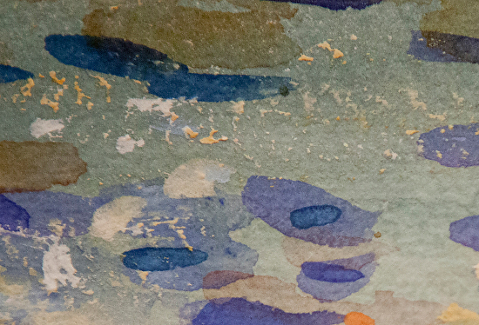"Brook Among Rocks" detail
by John Singer Sargent
- In either wet or dry paper,
- Often let shadows flow into wet light areas,
- Hardened and softened edges as necessary
Sargent's Watercolor Brushwork
Created apparent detail and object perceptions using both broad effects and individual brush strokes; defined only what he wanted to define, and left a lot quickly stated
Often speedily executed, but with accuracy
Endless variety of brushstrokes; hard, soft, drybrushed, worked over, painted wet-in-wet, scraped with a knife or fingernail; seemingly using the largest brush suitable to the task
Used calligraphic brushstrokes to summarize form and movement
Sometimes re-wet a dry shadow passages with clear water and developed some modeling into that area.

Critiques
When [Ms Henn and fellow students] were gathered in front of our display of sketches for composition awaiting some criticism, Sargent would walk along the whole collection, rapidly looking at each one, and without singling out any in particular for comment, he would merely say: Get in your mind the sculptor's view of things, arrange a composition, decoratively, easy, and accidental.

This would be said in a hesitating manner, and then he would quietly retire. On one occasion, when the subject set for a composition was a portrait, the criticism was: "not one of them seriously considered." Many we had thought quite good, as an indication of what might be tried while a portrait was in progress. That would not do for Sargent. A sketch must be seriously planned, tried and tried again, turned about until it satisfies every requirement, and a perfect visualization is attained. A sketch must not be merely a pattern of pleasant shapes, just pleasing to the eyes, just merely a fancy. It must be a very possible thing, a definite arrangement -- everything fitting in a plan and in true relationship frankly standing upon a horizontal plane coinciding in their place with a prearranged line. As a plan is to a building, so must the sketch be to the picture.

Sargent On Learning to Paint
He thought it was excellent practice to paint flowers, for the precision necessary in the study of their forms and the pure brilliancy of their color. It refreshed the tone of one's indoor portraits, he insisted, to paint landscapes or figures out of doors, as well as to change one's medium now and then. He disliked pastel, it seemed to him too artificial, or else it was made to look like oil or watercolor, and in that case why not use oil or watercolor?

Cultivate an ever-continuous power of observation. Wherever you are, be always ready to make slight notes of postures, groups and incidents. Store up in the mind without ceasing a continuous stream of observations from which to make selections later. Above all things get abroad, see the sunlight, and everything that is to be seen, the power of selection will follow. Be continually making mental notes, make them again and again, test what you remember by sketches until you have got them fixed. Do not be backward at using every device and making every experiment that ingenuity can devise, in order to attain that sense of completeness which nature so beautifully provides, always bearing in mind the limitations of the materials in which you work.

Carolus-Duran’s Teachings
“In art, all that is not indispensable is unnecessary" was one of the precepts which Carolus-Duran, Sargent’s teacher, had formulated after his study of Velasquez. He urged his students to make copies of the pictures of Velasquez in the Louvre, not laborious copies, but copies "au premier coup."

From Velasquez he had learnt to simplify. His teaching was focused on the study of values and half-tones, above all, half-tones. Here lies, he would say, the secret of painting, in the half tone of each plane, in economizing the accents and in the handling of the lights so that they should play their part in the picture only with a palpable and necessary significance. Other things were subordinate.

Sargent himself always recognized his debt to the teaching of Duran. At the height of his fame, when looking at a portrait by a younger painter, he observed to Mr. William James: “That has value. I wonder who taught him to do that. I thought Carolus was the only man who taught that. He couldn't do it himself, but he could teach it.”

Carolus-Duran had taught that: 'Objects in nature relieve one against each other by the relative values of light and shade which accompany and are a part of each local colour. An outline, a contour, is, as we all know, a pure convention... an accepted convention...' This description can be effectively applied to Sargent's portraits where the shapes and forms are never defined but implied by the positioning of planes of colour and seemingly random brush strokes.

Avoiding False Accents
In speaking to William James about avoiding false accents, Sargent said, “You must classify the values. If you begin with the middle-tone and work up towards the darks – so that you deal last with your highest lights and darkest darks -- you avoid false accents. That's what Carolus taught me. And Franz Hals. It's hard to find anyone who knew more about oil-painting than Franz Hals. That was his procedure. Of course, a sketch is different. You don't mind false accents there. But once you have made them in something which you wish to carry far, in order to correct them you have to deal with both sides of them and get into a lot of trouble. So that's the best method for anything you wish to carry far in oil paint.”

Understanding Sargent
No preparation in colour or monochrome was allowed, but the main planes of the face must be laid directly on unprepared canvas with a broad brush. These few surfaces -- three or four in the forehead, as many in the nose, and so forth -- must be studied in shape and place.

Sargent did not, however, begin by 'drawing a head on the canvas in charcoal and fixing it'. In contrast, though, he certainly did carry through his teacher's recommendations "to capture the envelope of a figure" and the dynamic relationship between the model's contours and what surrounds them'.

According to James Gurney, one of the keys of understanding Sargent is looking at the painting methods of his teacher Carolus-Duran, who had a somewhat unusual method compared to other academic teachers. In a nutshell he tended to block in the tones in discreet mosaic-like patches at first (like a plane head, if you're familiar with those things) and then later in the game you blend the patches into each other.
Regarding starting with the middle tones, James Gurney believes that right away you want to make your big value statement (or the 'effet' as they called it), but you should reserve your very darkest accents and lightest highlights for final, carefully considered touches.

