Texture

Wikipedia definition of Texture in painting refers to the look and feel of the canvas. It is based on the paint, and its application, or the addition of materials such as ribbon, metal, wood, lace, leather and sand. The concept of "painterliness" also has bearing on texture. The texture stimulates two different senses: sight and touch. There are four types of texture in art: actual, simulated, abstract, and invented texture.

Actual texture is a combination of how the painting looks, and how it feels to the touch. It is associated both with the heavy buildup of paint, such as an impasto effect, or the addition of materials.

Simulated texture involves creating the visual effect of texture without actually adding it. For instance, a texture may be created to look like something other than paint on a flat surface. An example is Cataract 3, painted in 1967 by Bridget Riley, which creates the illusion of ripples in the paper through the repetition of lines. 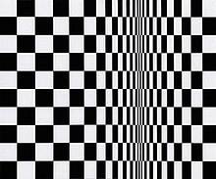

Abstract texture does not directly represent the object it is connected with, but the concept of the object is translated in textural patterns.

Invented texture is creative way of adding alternate materials to create an interesting texture. This texture typically appears in abstract works, as they are entirely non-objective.

Creative Ways to Add Abstract Texture to Painting

1. Sand and Grit
You can find painting mediums with sand or silica added to them, or you can add it yourself, so you have more control over the grittiness. Just remember, when adding sand, you may need to sift it, unless you want the natural grungy look. Use sand or grit for texture in landscapes (like sand/soil, tree bark). 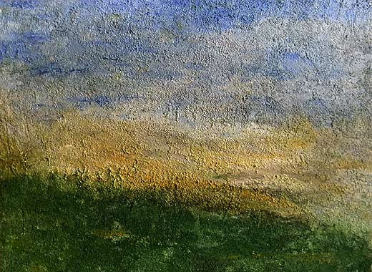

2. Poured Texture
Some artists are quite adept at adding color to a thick medium and pouring fantastic designs, make it thick but still pourable, and then create raised designs, lines and swirls, or even writing.

3. Combing
Use a variety of comb sizes and tooth openings. Combs can be used with inks, paint or other media. They can be used to create the linear patterns found in nature, or to create abstract dotting, swirls and lines.

4. Stamping:
You don’t have to buy stamps from stores, find interesting old pins, large button, shells, anything with a pattern and use to it to “stamp”. Use with color only, or medium, then stamp once, multiple times in a pattern, or organically. The thicker your medium, the more color your stamp will tend to pull up, leaving a jagged texture behind. 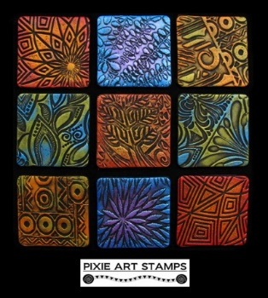

5. Stenciling
Make your own stencils by using thicker weights of paper or plastic materials. Use your imagination to create a stencil by lightly drawing it, and then carefully cutting it out using an Exacto knife. 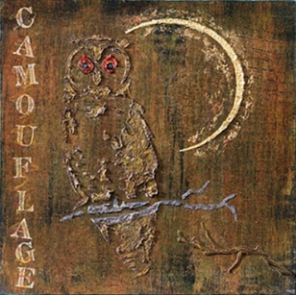

6. Sanding
When a textured layer of medium is dry, sand it down a bit to knock off the hard edges prior to adding paint. You can also use sanding to remove color.

7. Papers
Put down some medium, and then press cheesecloth or tissue paper into it. Bunch the cloth, a lot or a little, to leave varying amounts of texture behind. Use various kinds of archival papers to get texture applied with various gels and mediums.

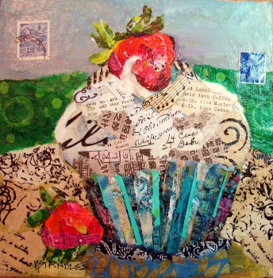
Paint on top so the papers are incorporated in to the piece, not just the icing on the top.

Acrylic texture gels and mediums are a fun, easy way to add a whole new dimension to acrylic paintings! The following information is from the Golden Paints Website, www.goldenpaints.com.

Gel Mediums offer many ways to build texture. We offer five consistencies from our most viscous Extra Heavy Gel to Soft Gel. Each gel is available in Gloss, Semi-Gloss and Matte finishes. They can be used to create glazes, extend paint and change finishes. Gels are essentially colorless paint, as they utilize the same 100% acrylic polymers as acrylic paint. Gels are also excellent adhesives for collage and mixed media, they dry with excellent flexibility with chemical, water and UV resistance.

Soft Gels are thinner than Heavy Body Colors. Mix with color to produce a brilliant glaze. Soft gels can be a base for wet blending and also as an adhesive for collage.

Regular Gels have the same viscosity as Heavy Body Acrylic Colors and are ideal for extending paint and regulating transparency without changing consistency. Useful for impasto
Heavy Gels are thicker than Heavy Body Acrylic Colors and may be blended with colors to increase body. Excellent for holding peaks.

Molding Paste
Pastes can be used to achieve a variety of effects and expressions. When used in conjunction with acrylic colors they broaden working properties and expand creative possibilities. Unlike gels, pastes are opaque because they contain Marble Dust or other fillers that create a white or clay-tone finish with a variety of textures and properties. Molding Paste can also be used to create foundations for painting either to create texture over a smoother surface, or to smooth out a textured surface. The absorbent qualities of Molding Paste make it suitable as a ground for nearly every painting and drawing media.

Molding Paste - Excellent for building surfaces and creating textures. Dries to a hard, yet flexible, opaque film. Blends with colors to tint and extend paint.
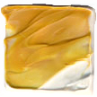
Extra Heavy Molding Paste - A blend of Extra Heavy Gel Gloss and Molding Paste. Dries to a satin, semi-opaque finish. Excellent for increasing viscosity and building surfaces.
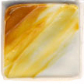
Hard Molding Paste - Dries to a extremely hard, opaque film, it is useful for creating tough, durable finishes for smooth or textured surfaces. Once dry, it can be carved with hand or power tools. Blends easily with acrylic colors.
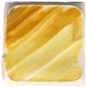
Light Molding Paste - Over 50% lighter than GOLDEN Molding Paste. This dramatic weight reduction is beneficial in creating large artworks and thick layers of material. Light Molding Paste dries to an opaque, matte finish with good flexibility. It is designed to hold stiff peaks for highly textured surfaces and it blends easily with colors.
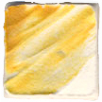
Coarse Molding Paste - thick, warm white colored medium, translucent up to about 1/8 inch thickness. Dries to a hard, stiff but flexible film with a tooth like fine sandpaper. Accepts wet and dry media very well. Mix with Fluid or Heavy Body Acrylics to create dense paint that holds good peaks and dries matte to satin with a finely pebbled surface.
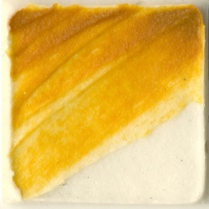

Gel with Aggregates

Clear Granular Gel is made with granular acrylic solids and has excellent clarity and durability with a coarse texture that dries translucent. Clear Granular Gel can extend paint and add texture without altering color.
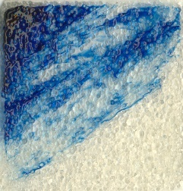

Glass Bead Gel made with genuine glass beads, offers a unique effect similar to condensation on glass - best seen in thin films over a light color to allow the glass beads to be illuminated.
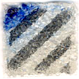
Pumice Gels textures dry to hard films. They mix well with GOLDEN Acrylic Colors. Fine Pumice Gel is useful as a drawing ground. Coarse Pumice Gel and Extra Coarse Pumice Gel create more coarse textures to yield concrete-like finishes.
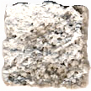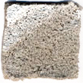

Effects Paste

Fiber Paste when dry has the appearance of handmade paper. It can be skimmed with a wet palette knife to make a smoother surface. The dry off-white color is absorbent, making it ideal for use with acrylic washes.

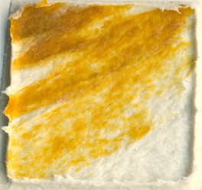
Crackle Paste is a thick, opaque material that cracks as it dries. The size and extent of the cracking pattern depends on the thickness of application, and environmental conditions during drying and other factors. Dries to an opaque, matte finish, with an absorbent surface suitable for acrylic paints and mediums.
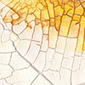

Tar and Leveling Gel

Clear Leveling Gel [formerly Self Leveling Clear Gel] produces an even film with excellent clarity. It has a unique resinous, stringy consistency resulting from its leveling property. Clear Leveling gel dries to a flexible, high gloss film while imparting a leveling quality to other GOLDEN Acrylic products. It blends well with GOLDEN Acrylic colors to produce glazes.
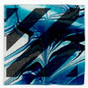
Clear Tar Gel has a pully, tar-like feel, but in a clear, colorless gel. This extremely resinous and stringy consistency makes it feel very different from other acrylic gels. Useful for generating fine detailed lines by "dripping" it over surfaces, as it continuously flows from palette knives or other tools. It blends well with all GOLDEN Acrylic colors, although Fluid Colors work best.
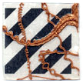

Special Purpose Mediums
GAC (short for Golden Artist Colors) Specialty Acrylic Polymers are based on 100% acrylic polymer emulsions. The GACs are useful as mediums or modifiers of acrylic paints. GACs can be used to extend acrylic colors, to regulate transparency, create glazes, increase gloss, reduce viscosity or improve adhesion and film integrity. GAC polymers can also be used for binding pigment solids for various effects and surfaces. Unlike the other GOLDEN Mediums and Gels, GAC Acrylic Polymers have only a minimum amount of thickeners, levelers, defoamers and surfactants to ensure good film formation.
The consistency of the GAC polymers is more fluid and thin than other GOLDEN Mediums, so they will reduce the thickness of most GOLDEN Acrylic Paints. GOLDEN Fluid Acrylics are slightly thicker than the GACs but will exhibit less change in viscosity with the addition of a GAC polymer.
Each GAC is a unique polymer with unique benefits and applications. Refer to the product descriptions below to find the proper medium for a particular applications.
GAC 100 is a thin, translucent, gloss medium. Useful for thinning or extending colors as well as increasing flexibility. Wets out solids more readily than other polymers and is useful for creating homemade paints. GAC 100 provides basic protection from Support Induced Discoloration.
GAC 200 Hard acrylic extender for non-porous surfaces is the hardest and least flexible polymer we offer. It is Ideal for mixing with acrylic colors to increase film hardness, reduce dry film tack and to increase adhesion to many non-porous surfaces. Dries to a clear, high gloss, finish. GAC 200 is not recommended for flexible supports.
GAC 400 Stiffens natural fibers and fabrics and is useful for stiffening unprimed canvas or sculpting and shaping fabric. Fibers saturated with GAC 400 will dry to a hard, stiff film.
GAC 500 Gloss extender for Fluid Acrylic Colors is a unique balance of film hardness and flexibility offering increased leveling, increased mar resistance and decreased dry film tack. GAC 500 is particularly useful for extending Fluid Acrylic Colors with minimal property change. It can be mixed with Airbrush Transparent Extender for a fast-drying, sprayable isolation coat.

GAC 800 is a low-crazing extender for pouring acrylic colors. "Crazing" is the formation crevices in surfaces that develop as acrylic paints and mediums dry. The addition of GAC 800 promotes drying with a smooth, even film, good gloss and flexibility, but with moderate clarity. GAC 800 is also useful for adhesion to chalky surfaces.

Color Pouring

Mix Heavy Body, Fluid, or High Flow Acrylics into GAC800 for an almost opaque, glossy and level appearance. Colors hold their edges when poured wet into wet. Gently mix 10 parts GAC800 with 1-part acrylic color, allow mixture to sit covered (ideally overnight) to eliminate air bubbles. Pour close to the surface to reduce air bubbles.
Paintings may need to dry for a few days before moving. Do not pour thicker than 1/8” (3mm) or attempt to accelerate drying. For detailed instructions on pouring paints, see the Golden Paint application guide or videos featuring a big pour with GAC800.

