Zorn Limited Palette
By Michael Lynn Adams
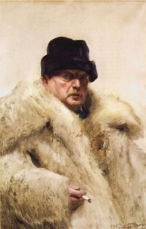
Andres Zorn

The Zorn limited palette is named after renowned Swedish artist Anders Leonard Zorn (February 18, 1860 – August 22, 1920). Best known for his portraits, domestic scenes and nudes in outdoor settings, he like John Singer Sargent and Joaquín Sorolla, are greatly admired by many realist artists today for his lively and skillful brushwork.
Zorn is also known for using a palette limited to just four colors. Although there is some disagreement over the exact colors on his palette it is generally believed that Zorn reduced his palette to the rather earthy colors of Yellow Ochre, Cadmium Red Medium, Ivory Black plus White. Some lists add Vermillion, Viridian, and/or Cerulean Blue. Wherever the truth lies the palette is far more limited in color range than most artists use today.
Why Yellow Ochre, Cadmium Red Medium, and Ivory Black? They are an earthy version of the primary pigment colors Yellow, Red and Blue. Yellow Ochre is earthy but still mixes with red and black to create some very pleasant warm orange hues and cool green hues respectively. Cadmium Red is rich and warm. Ivory Black is cool and acts like very deep blue.
Curious about what happens when you work with a bare bones palette I tried a little exercise borrowed from Alla Prima II Everything I Know about Painting–And More by Richard Schmid. I created a color chart using the basic Zorn palette of Yellow Ochre, Cadmium Red Medium, Ivory Black and Titanium White.
Instructions for creating a Zorn limited palette grid
This exercise involves creating a color chart where the basic Zorn limited palette of Yellow Ochre, Cadmium Red, and Ivory Black are systematically mixed from fully saturated hue to barely tinted white. The resulting chart demonstrates the remarkable range of colors you can get from this basic palette. I also discovered the beautifully harmonious color combinations that are created by using this palette.
STEP 1: Draw the Grid
On a 16-inch x 12-inch canvas panel draw a grid of 1-inch squares, 12 across and 10 down.

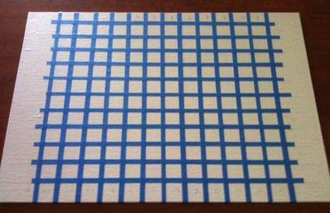
STEP 2: Mask the Grid
Using house painter’s masking tape cut into 1/4 inch wide strips, mask the edges of the 10 rows and 12 columns creating squares in which mixed colors will go.
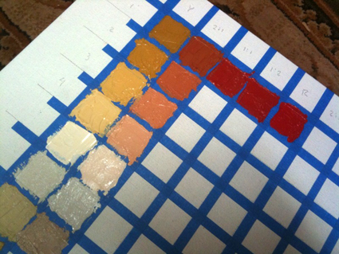
STEP 3: Mixing and Painting the Grid
Using a small palette knife or brush, paint the grid with the colors mixed as follows.

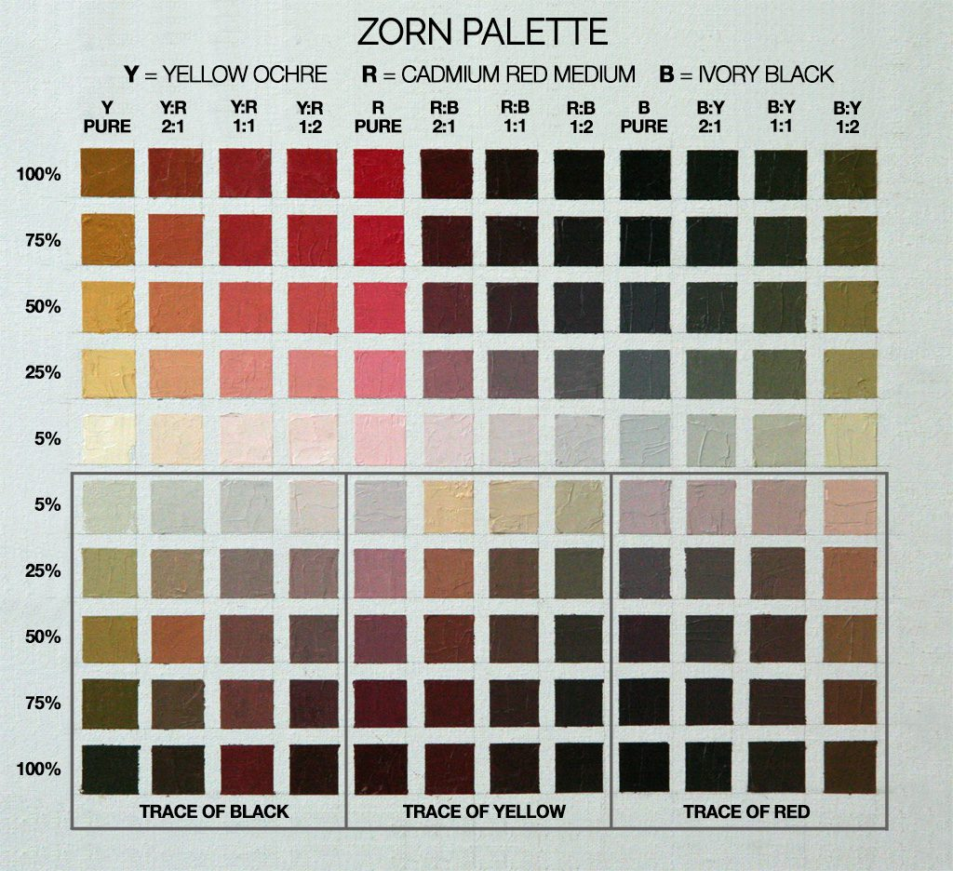
Top Row:
Colors straight out of the tube in columns 1, 5 and 9. The other mixed colors establish a base of secondary colors (oranges, purples and greens), by mixing sets of two primaries each – Yellow & Red; Red & Black; Black & Yellow – in the ratios noted on the Zorn limited palette chart. Do not add white to the first row.
Next Four Rows:
Mix white with the color at the top each column. The objective is to create a 5-stage progressively lighter value of each top row color. Listed on the left side of the guide is the approximate percentage of the top row color mixed with pure white for each row. Your goal is to create a gradual but clear series from the pure color to a light tint of that same color.
Bottom Five Rows:
Here you explore the tertiary colors. When using this limited palette the tertiary color are mostly in the brown to pink family. You will also discover some lovely flesh tones. The progression is the same as the upper grid but with the addition of a third color. In this exercise you will be adding the third color mix. For example, in the columns where Yellow Ochre and Red were mixed add a trace of Ivory Black. Carefully mix in a little pigment at a time – just enough color to see a shift in hue. You should also see the color’s temperature shifting as the third color is added.
TIPS
Mix One Column At A Time
Mix a large puddle of pure colors first and divide it into five smaller puddles. Then add white to each puddle to create the gradually lighter mixes. After those colors are painted on the grid, add the third, trace color, to each mixture to use in the lower half of the column.
Keep Your Palette and Colors Clean
Clean your palette, brush or palette knife after you finish each column to keep your colors clean.

THE ZORN PALETTE – M. Graham & Co. walnut-based oils
Yellow Ochre
Cadmium Red
Ivory Black
Titanium White

