What is Color Temperature?
Temperature is the relative warmth or coolness of a color.
Let’s take a look at the colors on the wheel below.
Yellow or any color with yellow as a predominant component is considered warm.
Any blue or color predominantly blue is considered cool.
Red looks like it’s in the middle of the temperature scale, and its temperature is relative to the colors next to it. It’s cooler than yellow, but warmer than blue.

Color Wheel
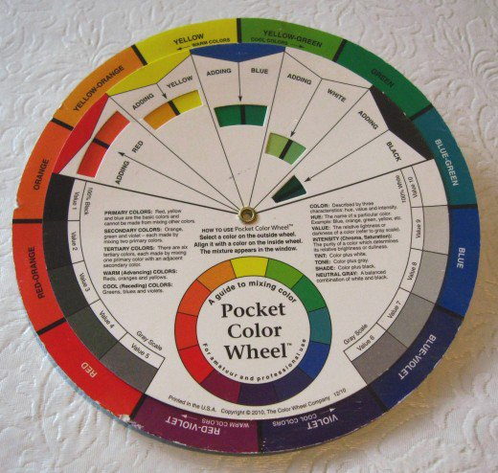

Color Temperature Relativity
When you are determining comparative color temperatures, keep in mind where they would place on the color wheel, and their relative proximity to yellow or blue.
The colors closest to yellow on the color wheel are warmer.
That said, it's important to remember that warmth or coolness of a hue is not absolute, but it's strongly related to what colors are around it.
For example:
When you paint red-violet next to red, then the red-violet appears cooler, because it contains some blue.
However, when red-violet is placed next to blue, then the red-violet is perceived as a warm color.
In other words, when in doubt, you can determine if a color is warmer or cooler by asking yourself if it has more yellow or more blue in it.
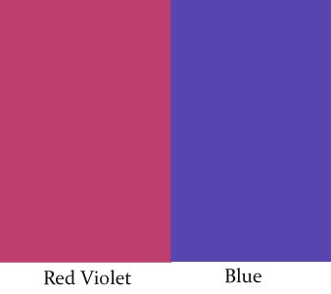
When red-violet is placed next to blue, then the red-violet is perceived as a warm color. "

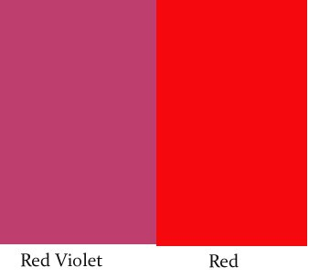
When you paint red-violet next to red, then the red-violet appears cooler, because it contains some blue."

The Power Of Color Temperature
For beginner painters, understanding color temperature and learning how to control the temperature of the colors you mix can improve dramatically the quality of the paintings.
Controlling temperature you’ll be able to:
- Create depth
- Create a sense of sunlight
- Define relationships between different objects and parts of the same object
- Establish a specific mood for your painting
"Learning how to control the subtleties of color temperature can do wonders for your paintings."

Cool Paintings and Warm Paintings
Each color, depending on its temperature, can be associated with a mood. You can learn to manipulate temperature and trigger certain emotions associated with your painting in a way that allows you to infuse your artwork with a very specific feeling or perception.
Warm colors are generally considered exciting and energizing, but also homely and earthy. A painting that is predominantly warm shines with glow and radiance.
Cool paintings can be more calming, soothing, and meditative. At the same time a cool color scheme can convey a sense of coolness and stillness. In some cases cool colors can be associated with a sad feeling.

Color Temperatures and Associated Emotions
Cool Temperature | Warm Temperature
Tranquilize | Exciting
Meditative | Cozy
Soothing | Earthy
Calming | Energizing
Quieter | Dramatic
Cooler | Fiery
Cold | Warmth
Sadness | Comfort

Temperature is the relative warmth or coolness of a color.

Warm Colors Advance and Cool Colors Recede.
In painting, we are facing the tough challenge of trying to represent a 3D scene on a 2D surface.
For a successful representation of depth in your painting, consider that warm colors advance and cool colors recede. This is a very important understanding when you are painting distance.
As Kim Casebeer told us during her oil painting workshop, “Yellow falls out first.”
This means that everything painted in yellow or very warm colors will tend to come forward in your painting.
If you paint the background yellow it will compete with the foreground and fight to come forward, pushing back any cooler objects in front of it.
Sometimes things at the horizon are really yellow and it’s tricky to make a decision on how to render them in a way that they do fall back and look far away.

Understanding color temperature and learning how to control the temperature of the colors you mix can improve dramatically the quality of your paintings."
Atmospheric Perspective
In general, as objects are more distant from us, the atmospheric perspective influences their color. Objects in the distance become:
- Cooler
- Duller
- Lighter in value
Apply these three rules to your distant objects, and even yellows at the horizon will read right to the viewer, because even being yellow, they’ll be a cooler, duller, and lighter yellow than closer objects.

Hues from the Color Wheel
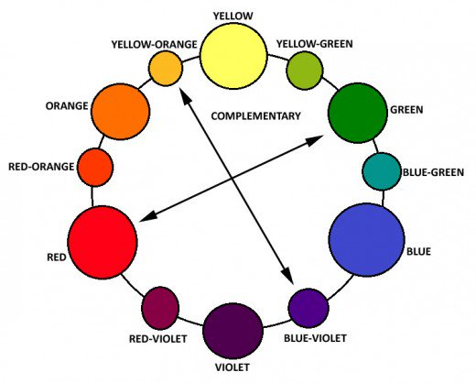

How Do You Dull a Color
The rule of thumb to dull a color is to add a bit of its complementary color.
To know which colors are complementary, look at the color wheel: they are opposite to each other.
Below is a table listing for each color the complementary that dulls it.
Note: Some colors are particularly opaque and strong, and just a little bit added can change drastically your color mix. Always start by adding a tiny amount of the complementary, mixing, and evaluating if you need to add more.

Colors that Mixed together will Dull Each Other
Hue from Color Wheel | Its Complementary Color
Yellow | Violet
Yellow-Green | Red-Violet
Green | Red
Blue-Green | Red-Orange
Blue | Orange
Blue-Violet | Yellow-Orange
Violet | Yellow
Red-Violet | Yellow-Green
Red | Green
Red-Orange | Blue-Green
Orange | Blue
Yellow-Orange | Blue-Violet
The rule of thumb to dull a color is to add a bit of its complementary color.

Why Painting Value/Tone Is More Important Than Color

What Is Value in a Painting?
When we describe a color as "light" or "dark", we are discussing its value or "brightness". This property of color tells us how light or dark a color is, based on how close it is to white.
The lighter the color, the higher is its value. For instance, lemon yellow would be considered lighter than cerulean blue which in turn is lighter than black. Therefore, the value of lemon yellow is higher than cerulean blue and black.

The Value Scale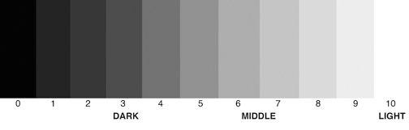

The Value Structure Is the Skeleton of a Painting
For the success of a painting, a painter should approach it as a value problem, an arrangement of light and shadow. Value is the skeleton upon which the painting is constructed; color and detail add local interest.
- Value contrast is used to create a focal point within a painting or drawing.
The human eye is immediately drawn to a light element against a dark element. This creates the focal point of interest.
- Gradations of value are also used to create the illusion of depth.
Areas of light and dark give a three-dimensional illusion of form to subject matter
Value means light or dark, an essential element in drawings and paintings. Learn how value is the key to a successful painting, not color. How to understand and see values in art. | Source

Using the Value Scale to Find Color Tone
The easiest way to remember this dimension of color is to visualize the "gray-scale," which runs from black to white and contains all of the possible monochromatic grays. This scale helps artists understand and identify light, mid-tones, and darks more easily.
You will have a better view of values if you squint your eyes, squeezing them as in bright sunlight. Looking through your eyelashes filters the colors out, letting you see values better.

Value Does the Work, Color Gets the Credit
Color is the most attractive quality of a painting but, believe it or not, value is more important than color to the design and success of a painting.
Think of a black and white movie. All you can see is made visible by value contrast. Color is totally extra to understand what is going on.
In the painting world, color is what viewers of will notice most, therefore the value of each color is important in determining the success of the composition.

How to Use the Color Wheel to Plan Color Schemes and Color Mixing

The Color Wheel: A Visual Tool
The color wheel is a visual representation of the colors found in a prism, arranged in a circle, with the primary colors (yellow, red, and blue) spaced evenly around.
Artists of all kinds—painters, quilt makers, web designers, graphic designers, interior designers, etc—use it as a basis for working with hues, shades, and colors.
It's a great tool to plan color schemes and color mixes.

Why Do I Need a Color Wheel?
What’s the point for an artist of keeping one handy?
The color wheel is a great start for getting inspiration on what color combinations and hues to use. It simplifies the processes of creating harmony or contrast by helping to choose the right color schemes.
Consulting this handy tool, artists can decide what color scheme they want to use by applying some geometrical methods, which means taking into consideration the distance between colors on the wheel.
More on the different schemes below.

Color Schemes
COLOR SCHEME | Colors Used
Monochromatic | One color and its tints, tones and shades
Analogous | Colors that are close to one another on the color wheel
Complementary | Colors that are directly opposite to each other on the wheel
Split Complementary | A color and then the two colors on each side of its complement
Triadic | Three colors that are equally spaced around the color wheel
Tetradic | Four colors that are two sets of complements

The Two Sides of the Color Wheel
On the front of the color wheel , all around the edge, you find the primary and secondary colors. In the center, there is an inside wheel has small “windows” that let you see what color you would obtain adding either red, yellow, blue, white, or black to the colors on the color wheel.
The inner wheel shows the results of color mixing. Rotating the inner wheel you can find a color that is the closest to what you are trying to mix, and learn how to mix it.
The wheel has also a gray scale that let's you verify the value of each hue, for example in the top photo red compares pretty well to a value 6.
On the back of the color wheel (bottom photo) you can see the scale of pure color, tint, tone, and shade, for each hue.
Also, in the center there is a diagram showing all the color schemes, and turning the dial you can see combinations of colors that would work together for each color scheme.

Color Temperature: Warm and Cool Hues
Each hue has a specific temperature. Temperature is the relative warmth or coolness of a color.
On the wheel, yellow or any color with yellow as a predominant component is considered warm.
Any blue or color predominantly blue is considered cool.
Red it’s kind of in the middle of the temperature scale, and its temperature is relative to the colors next to it. It’s cooler than yellow, but warmer than blue.
In general, you can determine if a color is warm or cool by asking yourself if it's closer to yellow or closer to blue on the wheel.
The warm colors, that cover one half of the wheel, are yellow/green, yellow, yellow-orange, orange, red-orange, and red.
On the other half are the cooler colors: green, blue/green, blue, violet/blue, violet, and red-violet.
When used on a painting, the warm colors tend to advance from the surface, and the cool colors tend to recede. This factor is useful in portraying depth.
The use of cooler colors for trees and objects in the distance, by making them more blue-green than those in the foreground, creates an effect of atmospheric perspective and suggests depth.

Hue Terminology
Hue is another word for color.
Different hues can be used to represent things realistically or dramatically, yielding totally different effects and feelings, depending on the colors combination used.
The primary colors on the wheel are yellow, red, and blue. From these three hues all other colors can be created.
In between each pair of primary colors are the ones obtain by mixing them, the secondary colors.
Tertiary colors are in between mixing primary and secondary hues.
If you purchase a 12-color set of paints, it will include all of the primary, secondary, and tertiary colors. Some artists purchase only the primary and secondary colors, and mix the tertiary colors themselves.
Hues opposite to each other on the wheel are complementary; the ones next to each other are harmonious.

Primary Colors
There are only three true hues: red, yellow, and blue. They are called primary because nothing can be mixed to produce them: they must be made or bought. With them we can make any other color, except white which is not an actual color.
Depending on the three primaries you choose from the large range of reds, blues and yellows you will get different secondary and tertiary colors.
The three primaries that the artists most use are: naphtol red, ultramarine blue, and cadmium yellow medium.

Secondary Colors
Mixing pairs of primary hues, we get orange, green, and violet, which are called secondary colors.
Mixing different secondary colors, you get chromatic neutrals, which is what you get when you mix all the primary colors in different proportions. While this effect is sometimes achieved unwilling, and takes the nick-name of "mud", it actually a great way to create low intensity, supporting hues.

Tertiary Colors
The tertiary colors are made by mixing one primary and one secondary color. There are six tertiary colors: yellow-orange, red-orange, red-violet, blue-violet, blue-green, and yellow-green.

Complementary Colors
Having a good understanding of complementaries can help you achieve satisfactory results in your paintings.
On the color wheel, each primary color is always opposite the color obtained mixing the other two primary colors. So red is always opposite to green, yellow to violet, and blue to orange.
The hues that are direct opposites on the color wheel are called complementary colors. These colors are contrasting, or conflicting, and they produce two different effects, depending on how they are used.
If we lay complementary colors next to each other, they will strengthen each other, and appear brighter than when separate, producing a vibrant effect. The hues don’t need to be used at their full intensity; muted versions will produce subtle but effective complementary contrast.
If we mix a complement into a color, it will tone it down. When a hue is too intense or bright, adding a bit of the complementary is a good way to make it duller.
Complementary colors can be used on the dark side of objects to produce a shadow.
Also, by mixing any two complementary together you can obtain a large array of chromatic grays and neutral colors.
Orange and green will create a brown, orange and blue a gray, and so on; varying the amounts of each color used in the mix, will result in different tones and values of color.

Harmonious Colors
Hues that are side by side on the color wheel are considered harmonious.
Examples are red, red-orange, and orange; yellow, yellow-green, and green; green, blue-green, and blue.
Harmonious colors create a pleasing combination, with low temperature contrast.

Tetradic Palette
The tetradic color scheme uses four colors arranged into two complementary pairs.
This rich color scheme offers plenty of possibilities for variation, and works best if you let one color be dominant.
To find the colors that work well together, rotate the inner wheel, and look at the corners of the square or the rectangle drawn on it, they'll point to the tetradic options.

Triadic Palette
A triadic color scheme uses colors that are evenly spaced around the color wheel, and creates vibrant color combinations, even when you use pale or unsaturated versions of your hues.

